BE 1 Exercises

Oct 30th

# Exercise 1 (Network inspect)

* Go one of the websites that you visit frequently using your browser What is the url ?

https://github.com

* Open the developer tools (Inspect) and answer the following :
* What is the IP address of the server host   
  20.233.83.145
* How many http(s) request were made 115
* What are the different types returned from all of the requests   
  Doc, JS, Fetch/XHR, CSS,Font, Img, Manifest, png
* What was the largest file returned   
  for_you_feed
* How many ms did it take?  
  799ms

# Exercise 2 (Simple Node Server)

* Go to<https://www.npmjs.com/package/http-server>
* Install the required packages
* Serve your website using the (http-server) On port 2
* Go to [http://localhost:2](http://localhost:2/)
* Open inspect > Network
* Take a screenshot and upload it

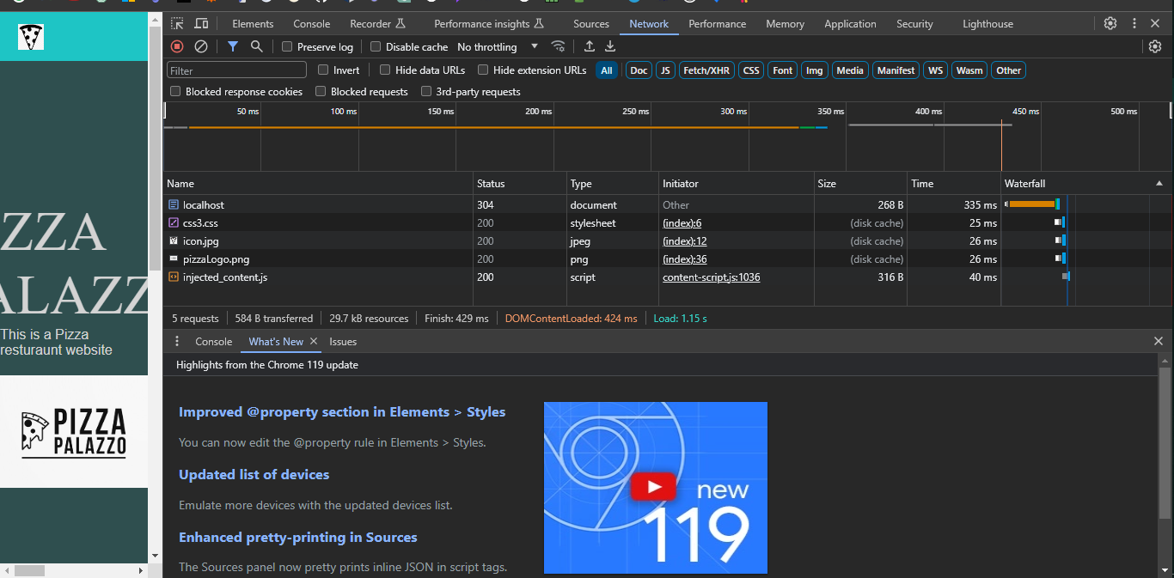

# Exercise 3 (Domain Name)

* Go to GoDaddy.com
* Find a domain name for your

Pizzapalazo.com